

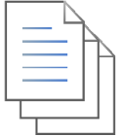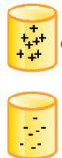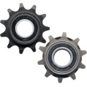

Classification agreement detection

**[Input]**

[Crowdsource Knowledge] (e.g., answers, questions)

**[Input]**

[Code quality metrics] (e.g., readability)

**[Input]**

**[Output]**

**Promoted** code examples

**Discouraged** code examples

Vote-based classification

Metrics-based classification

[Code examples]

Data cleansing

[StackOverflow votes]